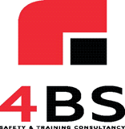
SAFETY TRAINING
ARE YOU COMPLIANT?
Courses Available: Manual Handling
Working at Height Fire Warden
Asbestos Awareness

Temporary Works Awareness Abrasive Wheels
For other Courses please call:
4 B'S S&T Consultancy Ltd Contacts:
Russell Broad
07551 949327
Russellb.4bs@gmail.com

Peter Barlow
07817 980811
Peterb.4bs@gmail.com
Free Initial Assessment of your business needs regarding training.
4B's Safety & Training Consultancy will carry out a free initial assessment of your company and
provide a no obligation written assessment of your training requirements
in line with current legislation.

